**September Monthly Report**

Zihan Qiao (Weibo)

**The workflow of Weibo in September**

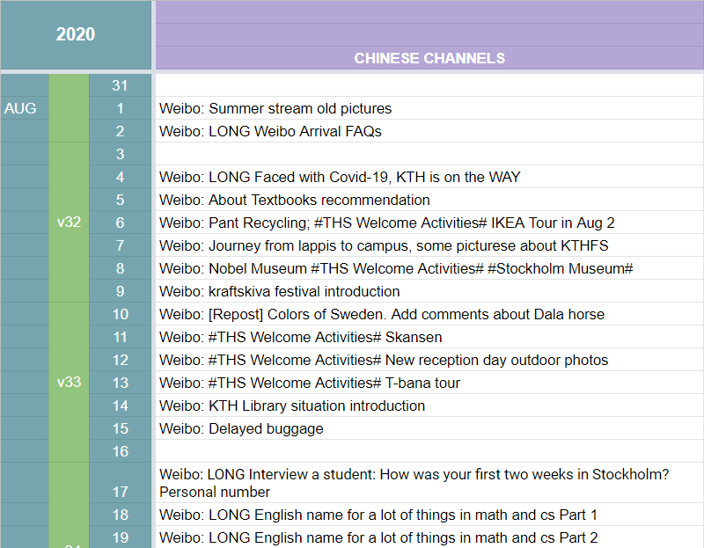

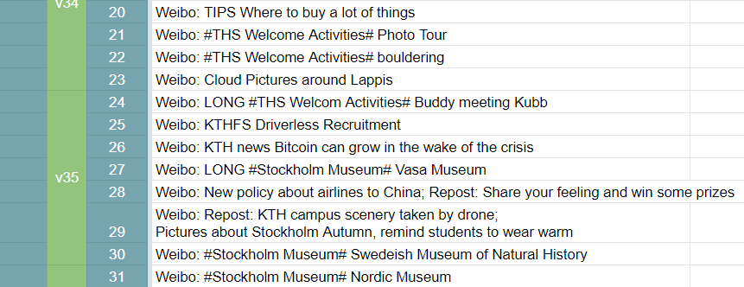

Figure 1 Content Sheet for August

**Statistics**

Until today (2020/9/2), the fans number in total is 17846.

|  |  |
| --- | --- |
| Current fans number (2020/9/2) | 17846 |
| Added number | 575 |
| Decreased number | 177 |
| Net increase | 398 |
| Unfollow initiatively | 172 |
| Average fans increase rate | 0.07% |
| Curve |  |

Table 1 The number of Weibo fans from July to August

|  |  |
| --- | --- |
| Weibo Total Posts Aug | 35 |
| Total Read | 319700 |
| Original Post | 31 |
| Repost | 4 |
| Long Passages Post | 8 |
| Hot topics | #Stockholm Museums#  #THS Activitites#  #KTH Research# |
| Curve |  |

**Shining point:**

1. The post on 3rd August. The title is “About KTH new life FAQ”. Very helpful for Chinese newly admitted students. Receive over 14 thousand Read.
2. New topics about Stockholm museums and THS activities.
3. Some warm-hearted tips in life.

**Weaknesses:**

1. Have not finished the topic about people on the Swedish Krone. Missed Birgit Nilsson and Dag Hammarskjöld.
2. Still few short videos!

**August Plan Check (From last month’s monthly report):**

Last year pride summer stream pictures Finished

New long passages series for Stockholm museums Finished

Finish the passage series for the figures on the notes. Unfinished

THS activities pictures! Finished

Plan to add short videos. The content and the editing technique. Unfinished

More academic research latest info from KTH Finished

Actually, that is a question that puzzles me. **Where can I find this kind of information?**

**September Plan:**

Swedish songs topic

Finish the passage series for the figures on the notes.

Actually have read a lot and watched documentary about Birgit Nilsson, but have not finished the passage.

Add more scenery pictures.

Organize an activity with my followers. Like write down your feeling about KTH. Repost and something like lottery draw. If we have some KTH related things which can be gifts.

**Personal feelings**

For now, I am quite familiar with the job. And I love this job!

I have my own working pace. And basically everyday one post. The topics are about KTH, Sweden culture, which is also my favorite. During the process of searching for information about KTH, I also gained more understanding about a lot of things, which is a positive-effect about the job.

Writing time: 2020/9/2 21:58-22:46